Modern Data Management & Business Intelligence

Assignment 1

Students: Eftychia Gkini & Skoli Maria
Registration Number: & p2822131
Class: Part Time

November 2021

Table of Contents
Introduction 3
Entity-Relationship Model 4
Relational Schema 5

Introduction

For the purpose of this Assignment we are going to delve into (embathinw giati oute egw tha to thimamai mexri aurio). To a real estate dataset based on the site E-Properties.
The line we will follow to perform our analysis is the following. First of all, we are going to design the Entity- Relationship Diagram which will be a great indicator of the existing relationship between the dataset. After that we are going to Create our Tables in SQL and we will insert our data for each table.
++ to be continued

Entity-Relationship Model

The first step of our analysis is to design the Entity-Relationship Diagram of our data. This will be the guide we will follow to perform our analysis. The E-R Diagram consists of entities, relationships, attributes and constraints. Due to the nature of our assignment, we observed that our data can be divided in 5 main entities: Agent , Estimation, Property and Region. Each entity has several attributes as we can see in the E-R Diagram below.
More specifically, the attributes of the entity Agent are: Name, Last Name, Gender, Age, Address and the ID of the Agent. The attributes for the entity Estimation are: the ID, the Date and the Price of the real estate estimation. The attributes for the entity Property are: the ID, Address, Floor, Size, Year of Construction and the Type of the apartment. The attribute Type has also the AFM and the Identity Number as attributes. Finally, Region entity has as attributes: the ID of the Region, the Name of the Region, the population and the average income.
The relationship that connects our entities is the following:
An Agent calculates one or more Estimations. An estimation is based on a specific property but a property can have multiples estimations. Finally, One or more properties are located in a specific Region.
The E-R Diagram is shown below. The app.diagrams.net is used for the design of the Diagram.

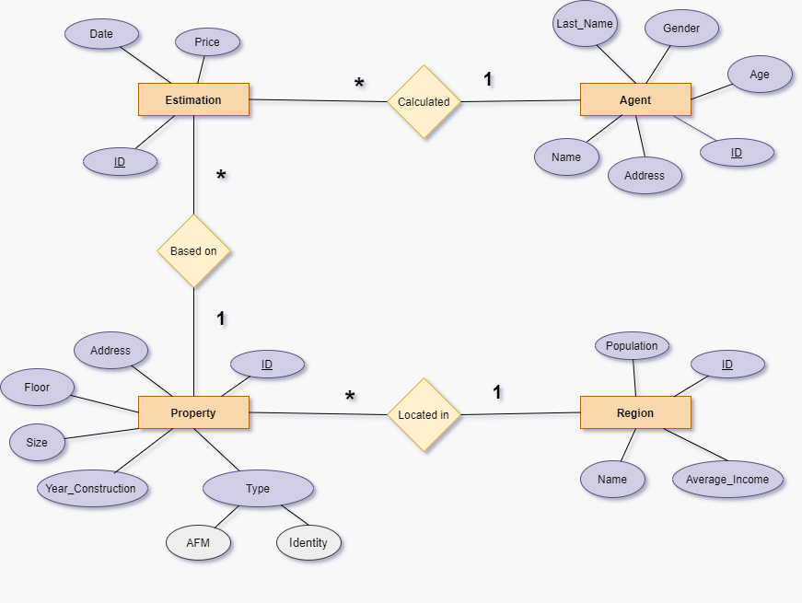
Figure 1: Entity - Relationship Diagram

Relational Schema

